REPORT FROM THE INTERNSHIP SUPERVISOR IN THE HOST ORGANIZATION

____________________________
(Date)

To ensure that the student's internship plan has been successfully fulfilled and that his/her work at the internship institution has contributed to his/her personal development as well as to the activities of the host organization, please fill in the following feedback form and pass it on to the student who has completed the internship. Your evaluation represents 30% of the final evaluation of the student's internship, so please fill in your feedback in a responsible manner.

Name of the practical training organization:
Student's name and surname:
Name, surname and position of the internship supervisor:
Period of the internship:

INFORMATION ABOUT THE STUDENT'S PERFORMANCE DURING THE INTERNSHIP:

Please comment briefly on the main activities the student has carried out and their results:

Please mark your rating | 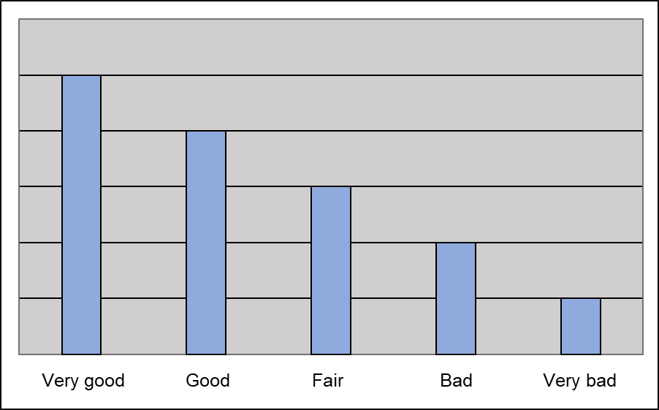
Evaluate student's progress during the internship period
Evaluate student‘s attitude to work (initiative, enthusiasm)
Evaluate student‘s academic training to complete the assigned tasks
Evaluate student‘s ability to solve emerging problems
Evaluate student‘s time management ability
Evaluate student‘s ability to plan and organize work
Evaluate student’s ability to collaborate with colleagues and professionals in other fields
Evaluate student‘s ability to accept criticism and respond constructively to it
Evaluate student’s effectiveness of communication skills

How would you rate the overall quality of the student's performance at the organization? | 1 | 2 | 3 | 4 | 5 | 6 | 7 | 8 | 9 | 10

Prepared by: __________________________________________________________________
(Name of the supervisor in the organization, surname, signature)

